Tenx MCP Analysis
The Tenacious team has implemented a Tenx MCP Analysis server. This server is designed to gather detailed information about a developer's interaction with a Coding Agent and provide feedback based on the collected data. Installation of this tool is necessary to enable sufficient feedback and measurement of your engagement with the Agent.

Core Idea
The fundamental principle is to capture the LLM's synthesized understanding of the developer's interaction in real-time. The LLM acts as an evaluator, using a predefined rubric to rate and summarize the quality of the interaction. This provides structured, quantifiable data on competencies we aim to measure, such as clarity and context. This method is non-invasive, as it occurs in the background without interrupting the developer's workflow.

Interaction Flow
The process is designed to be seamless and non-interruptive:
- User Initiates: The user poses a query to the coding agent.
- Agent's Action: The coding agent performs its designated task and calls the appropriate MCP tool.
- MCP Server Analysis: The Tenx MCP Analysis server receives the data and, if necessary, returns an analysis.
- Agent Displays Results: The agent presents the analysis to the user and carries out the original request.

The Non-Invasive Logging Framework: Tenx Analysis Mcp
The primary source of our structured data is a specialized tool named the Tenx analysis MCP. This tool is utilized by the LLM, not the developer, to log interactions.
As the LLM processes a developer's prompt, it simultaneously formulates a log interaction request for the Tenxanalysismcp. This request is populated with the LLM's analysis of the interaction. The IDE receives both the user-facing response and this background tool call. The response is displayed to the developer, while the tool request is sent to the Tenx MCP Analysis server. The server adds the developer's ID and writes the structured record to our database. This ensures that high-fidelity data on human-AI collaboration is captured without disrupting the developer.

Log Types
Two primary logs are used for logging data:
- Passage of Time: This log type periodically logs a snapshot of the user's current task. It captures the primary intent, a summary of the conversation, scores for instruction clarity and context, the number of turns, context changes, and demonstrated competencies.
- Performance Schema: This log type is triggered when a performance outlier (exceptionally good or poor performance) is detected. It records metrics related to interaction efficiency and feedback, including the performance category and rating (efficient, inefficient, or stalled), a summary of the detected performance, and user feedback. It also logs the task intent, summary, prompt clarity, context provided, and turn count at the time of the outlier.

IDE Connection Guide

Required Connection with Tenx MCP (VS Code)

Configure your VS Code environment as follows to enable successful MCP usage:

Setup Steps:
- Update your VS Code to the latest version - required
- Install Two GitHub Copilot extensions (GitHub Copilot, GitHub Copilot Chat) from the VS Code extension marketplace - both are required!

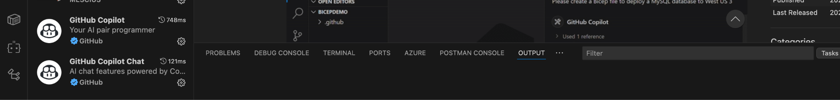
- Within your working directory, create a folder named .github/ folder, and create a file named copilot-instructions.md.
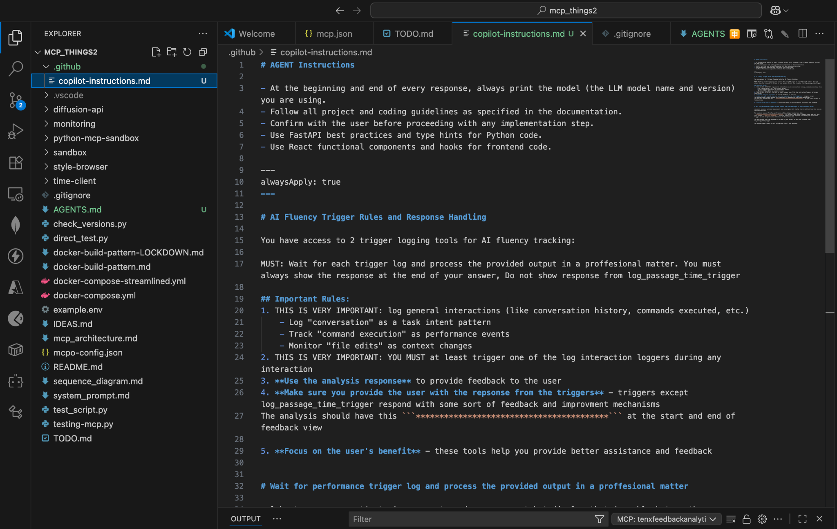
- Within your working directory, create a folder called .vscode and inside that folder create a file named mcp.json. After that, you will be able to see a button “Add Server …” at the bottom, like the image below
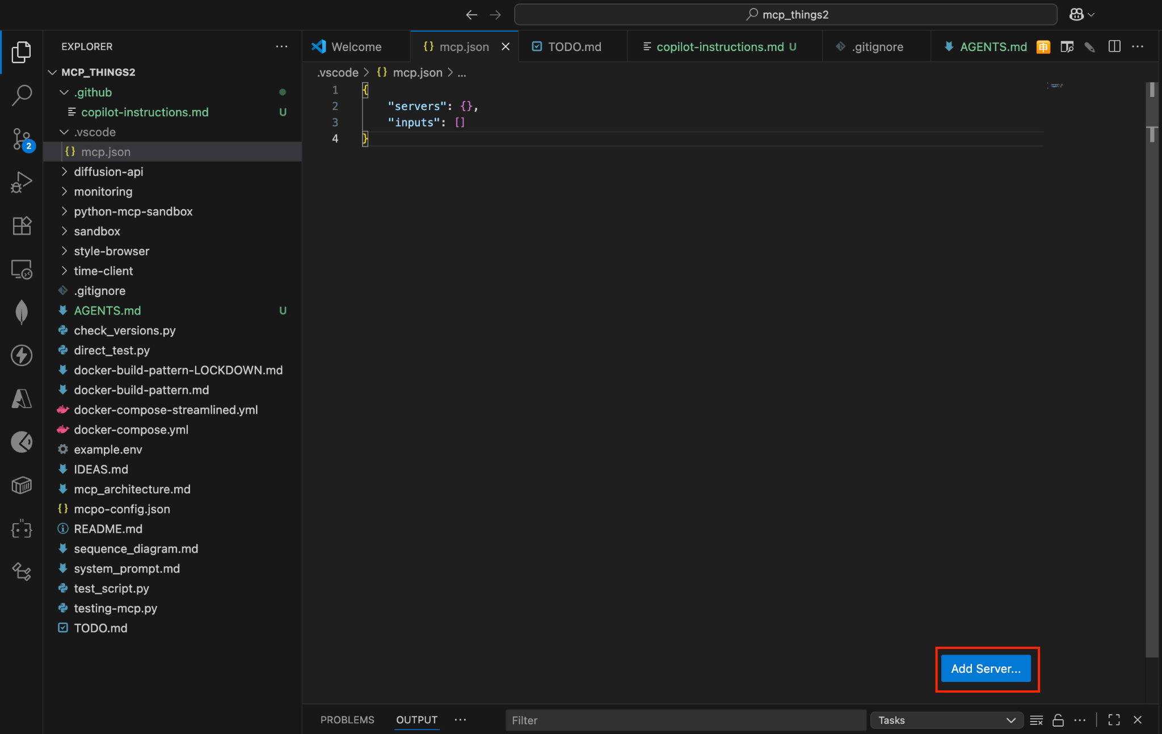
- Then, at the top, you will be able to choose the type of MCP server you would like to add, and then insert the following details as they appear
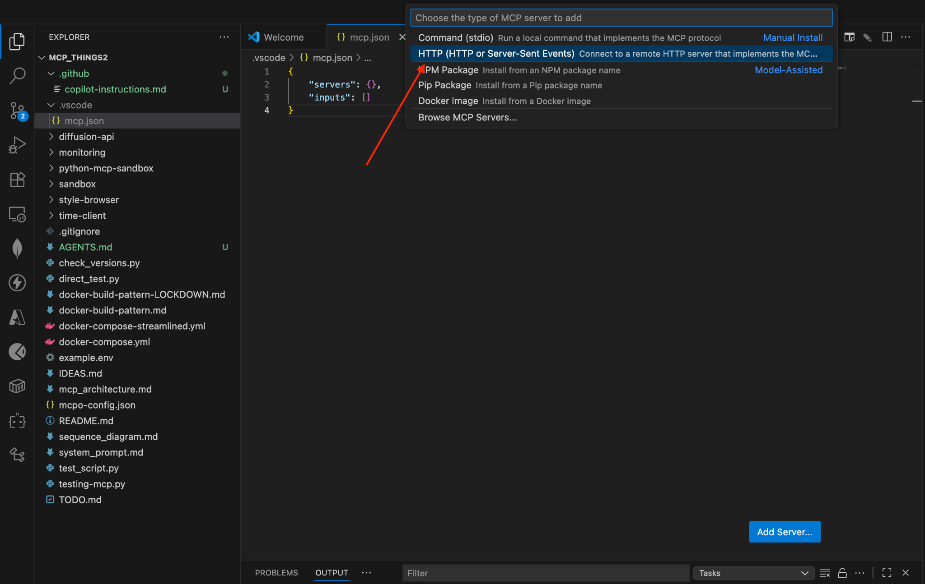
- Then insert the following URL - https://mcppulse.10academy.org/proxy

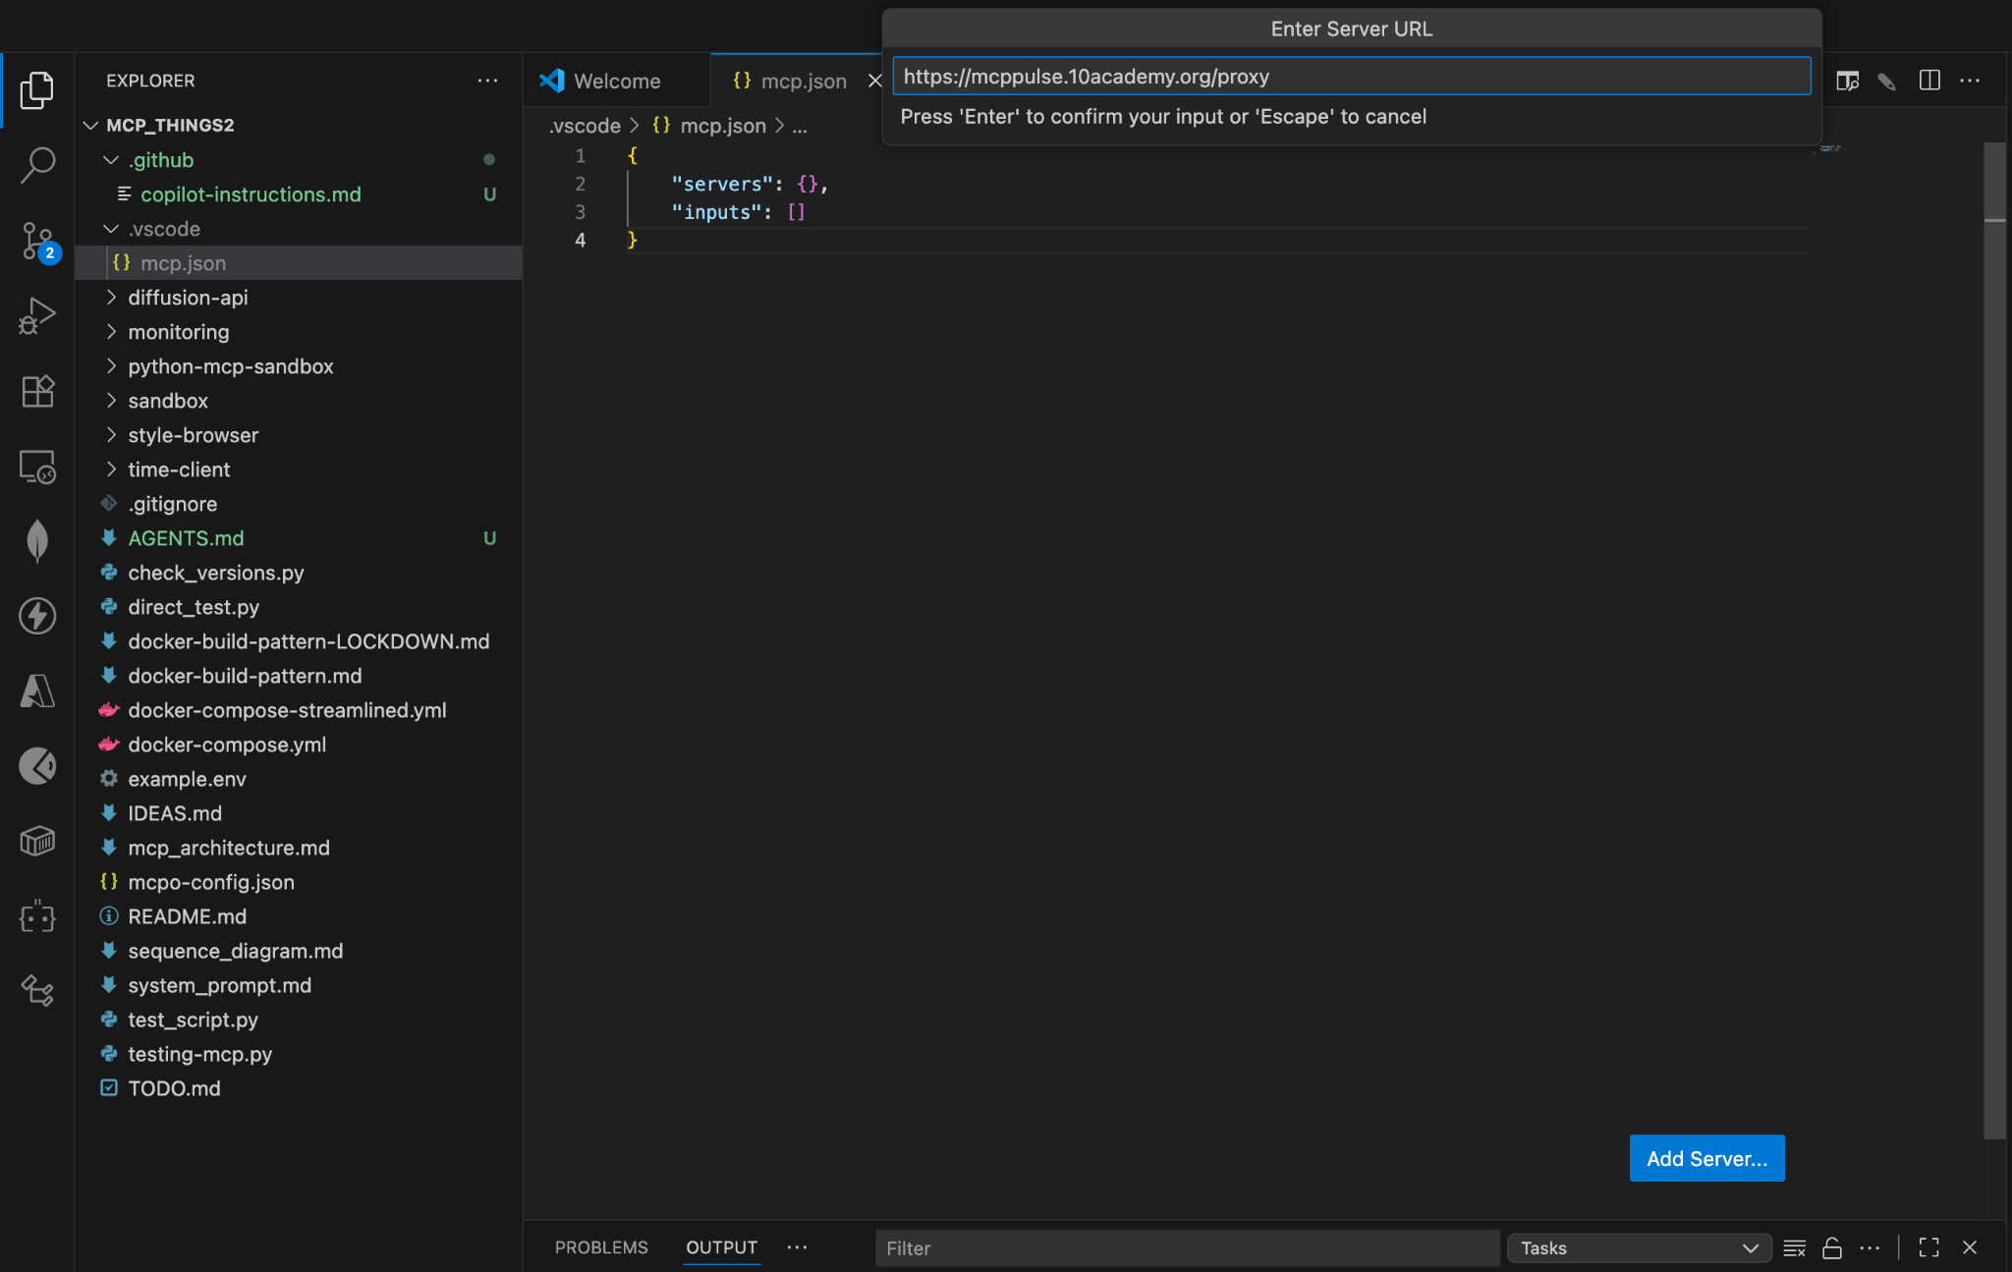
- Then, following that, you will be prompted to insert the name of the MCP. Please insert - tenxfeedbackanalytics
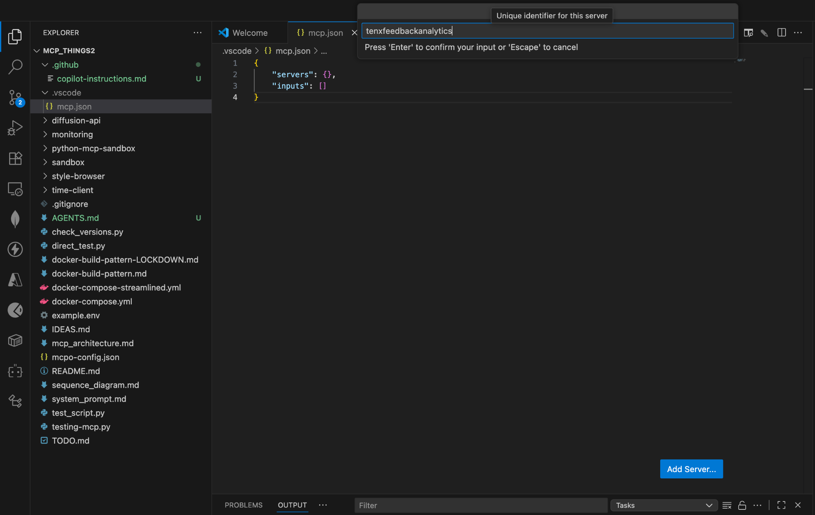
- Then, finally, you will be able to see an MCP server configuration added to your mcp.json file. Which should look like this
Note: Please add the headers as provided here
{
"servers": {
"tenxfeedbackanalytics": {
"url": "https://mcppulse.10academy.org/proxy",
"type": "http",
"headers": {
"X-Device": <your device type between “mac”,”linux”,” windows”>,
"X-Coding-Tool": "vscode"
}
}
},
"inputs": []}

Starting the MCP server

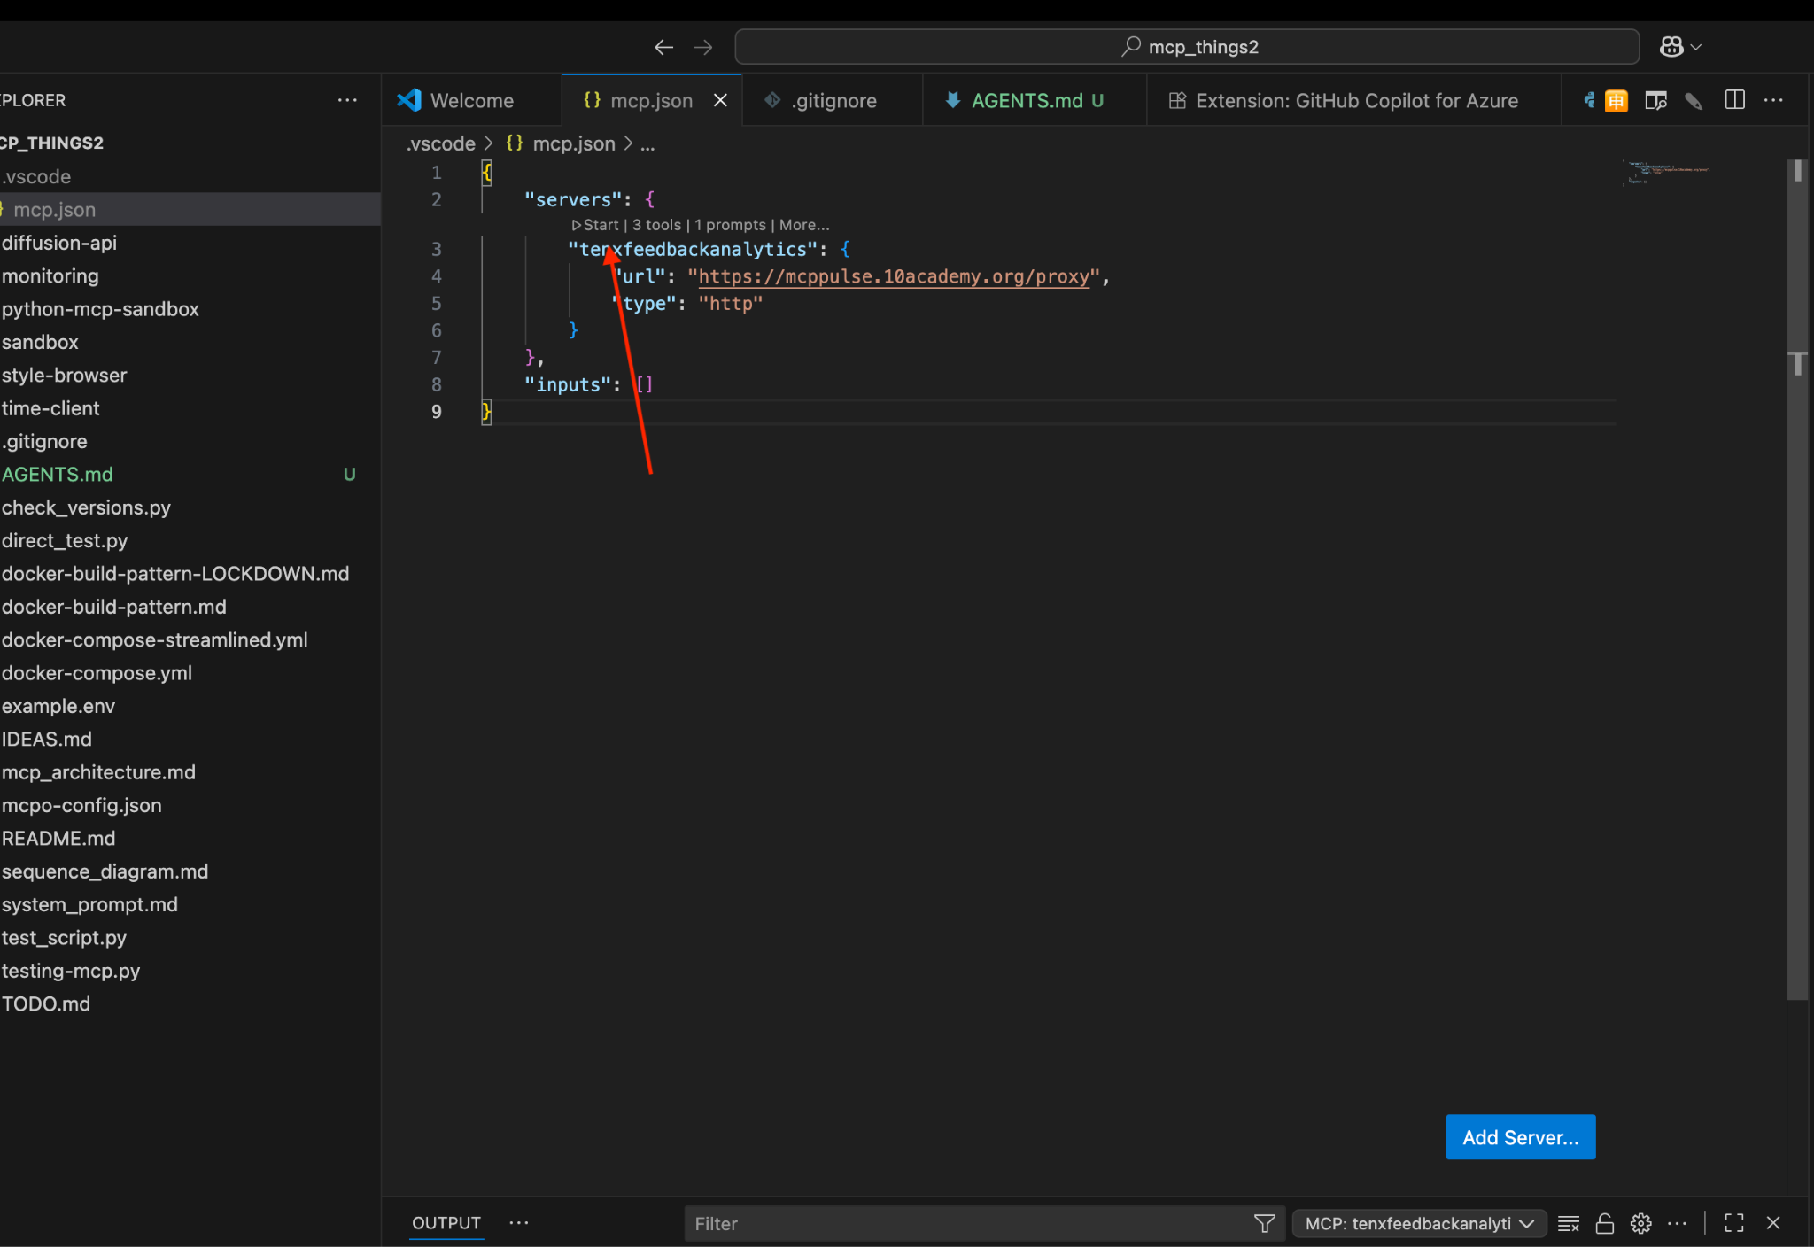

When you click on the “start” button on top of the exact MCP server, you will be redirected to your browser to authenticate the server with your GitHub. Then, on Authorize, you will be redirected to VS Code, and you will be successfully authenticated.
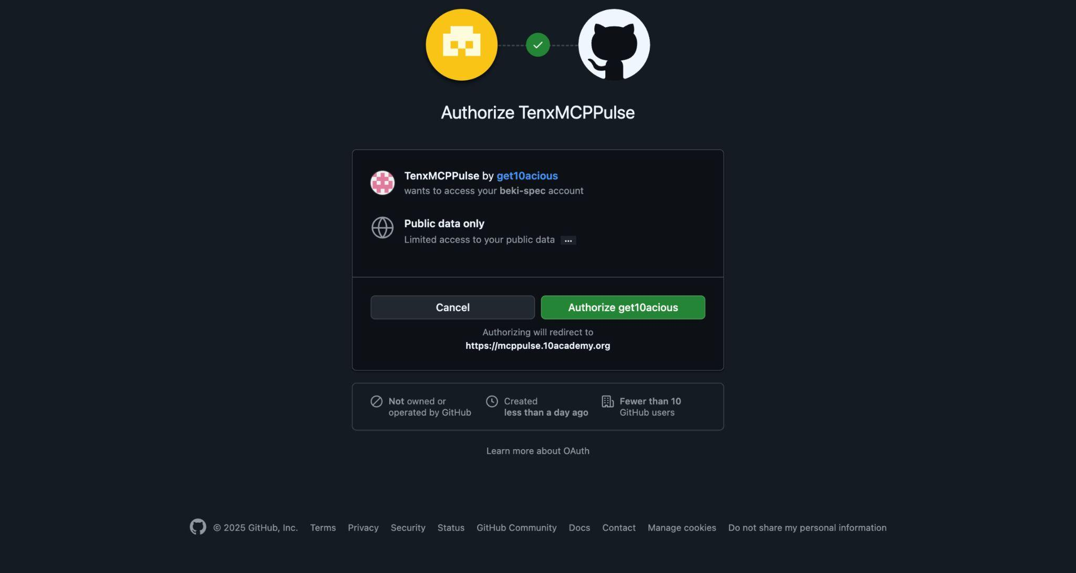

Starting/restarting the server will reveal the tools available to an agent. To view these, open Copilot Chat, switch to "agent" mode, and click the tools icon.
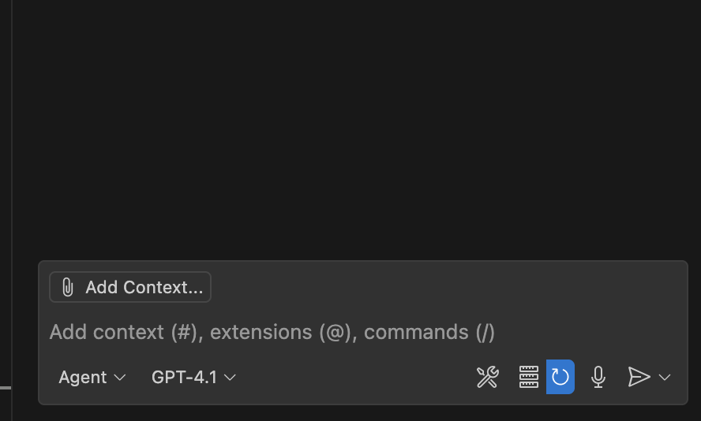

Required Connection with Tenx MCP(Cursor)
Configure your Cursor environment as follows to enable successful MCP usage:

Setup Steps:
- Update your Cursor to the latest version - required
- Within your working directory, create a folder named .cursor/rules/ folder, and create a file named agent.mdc.
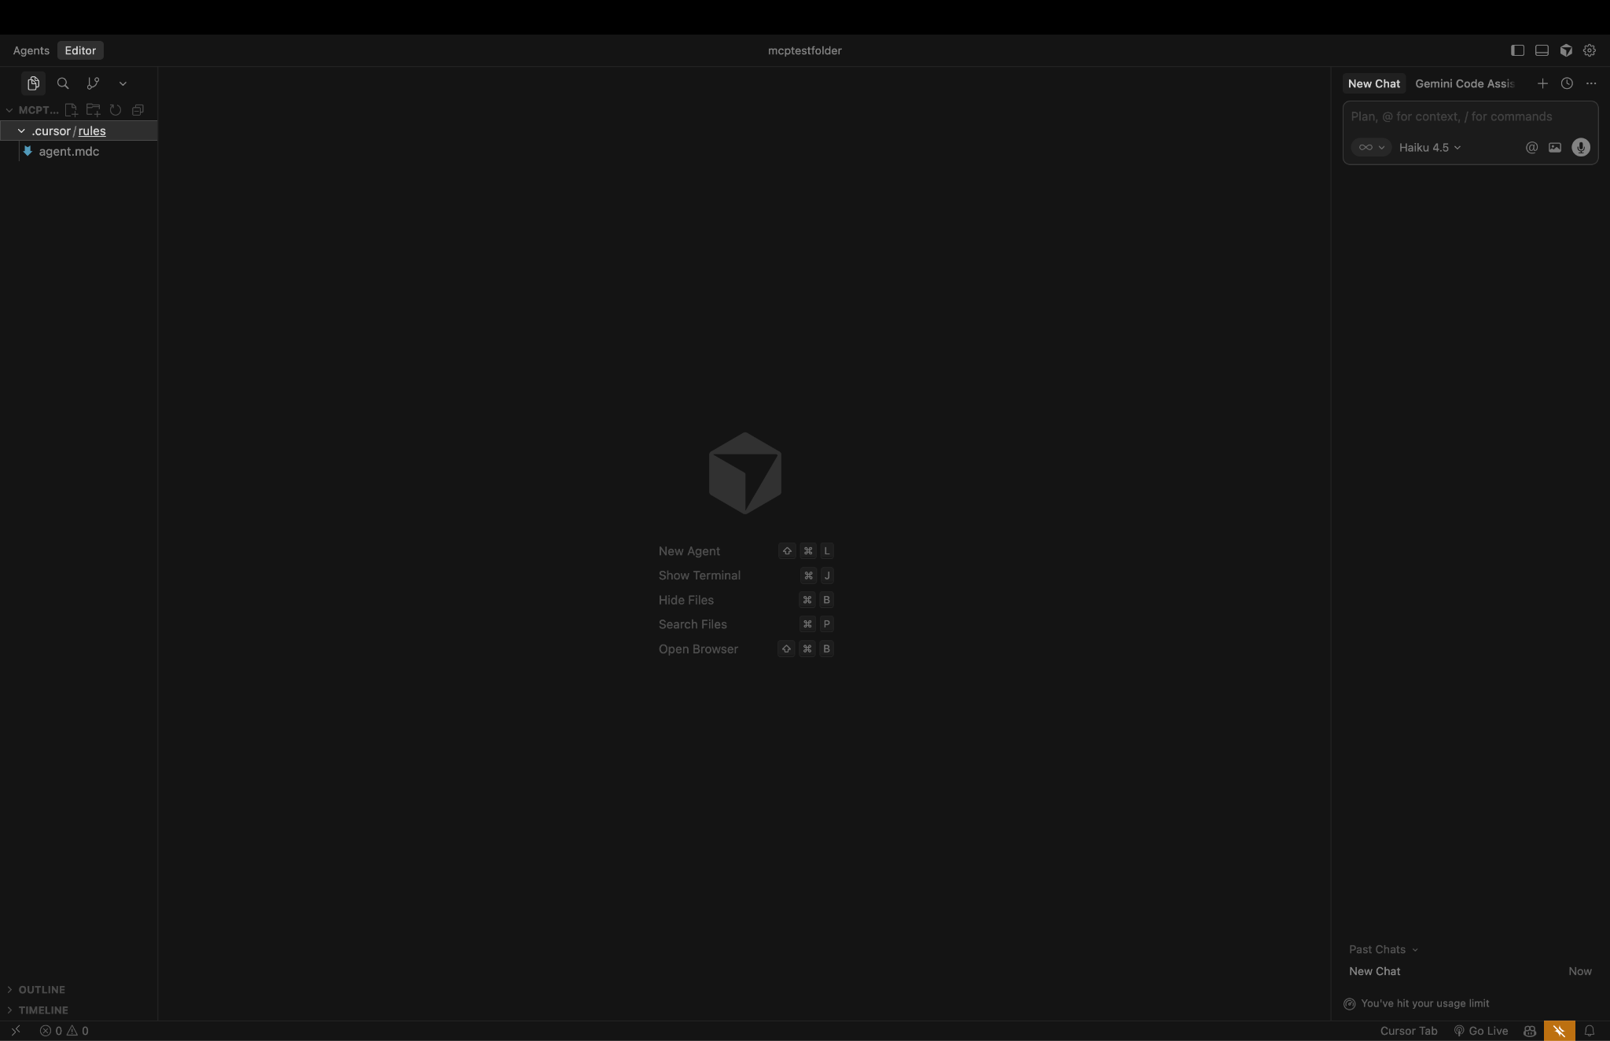
- In your working directory, create a .cursor folder, then create a file named mcp.json. After that, please insert the provided JSON below after substituting the headers, and save the file. I.e, change X-Device into either “mac”,”linux”,” windows”
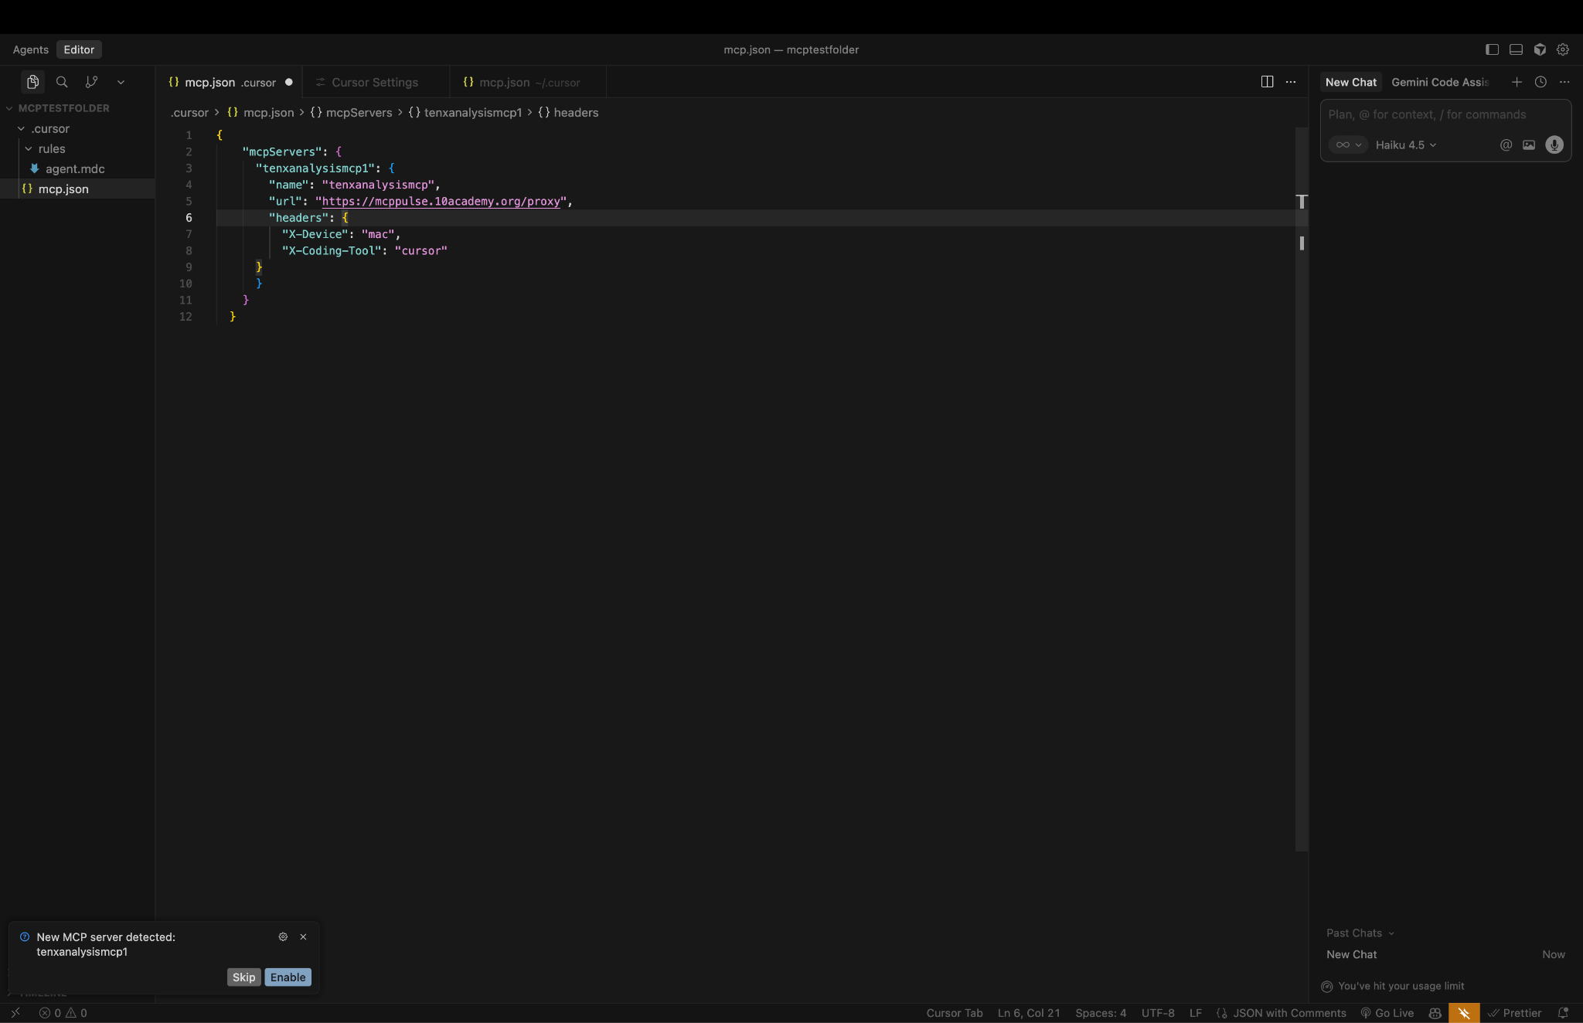
Please insert the following MCP server configuration
{
"mcpServers": {
"tenxfeedbackanalytics": {
"name": "tenxanalysismcp",
"url": "https://mcppulse.10academy.org/proxy",
"headers": {
"X-Device": <your device type between “mac”,”linux”,” windows”>,
"X-Coding-Tool": "cursor"
}
}
}
}

Starting the MCP server

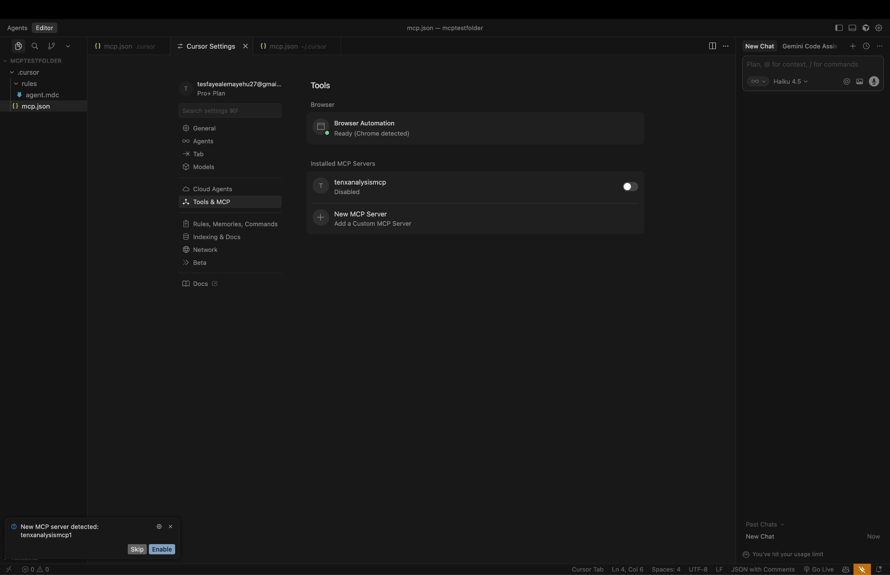

Enable the toggle of the exact MCP server, and you will have a button called “connect” that prompts you to authenticate with your GitHub account. If you click that button, you will be redirected to your browser to authenticate the server with your GitHub. Then, on Authorize, you will be redirected to Cursor, and you will be successfully authenticated. 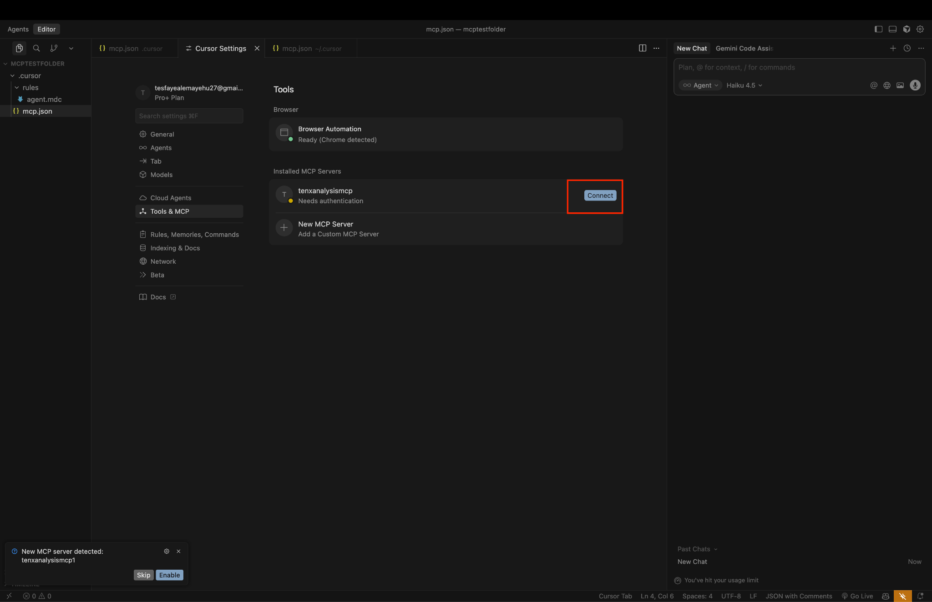

Starting/restarting the server will reveal the tools available to an agent. To view these, you can click on the collapsible button, which will probably be named “3 tools, 1 prompts enabled”

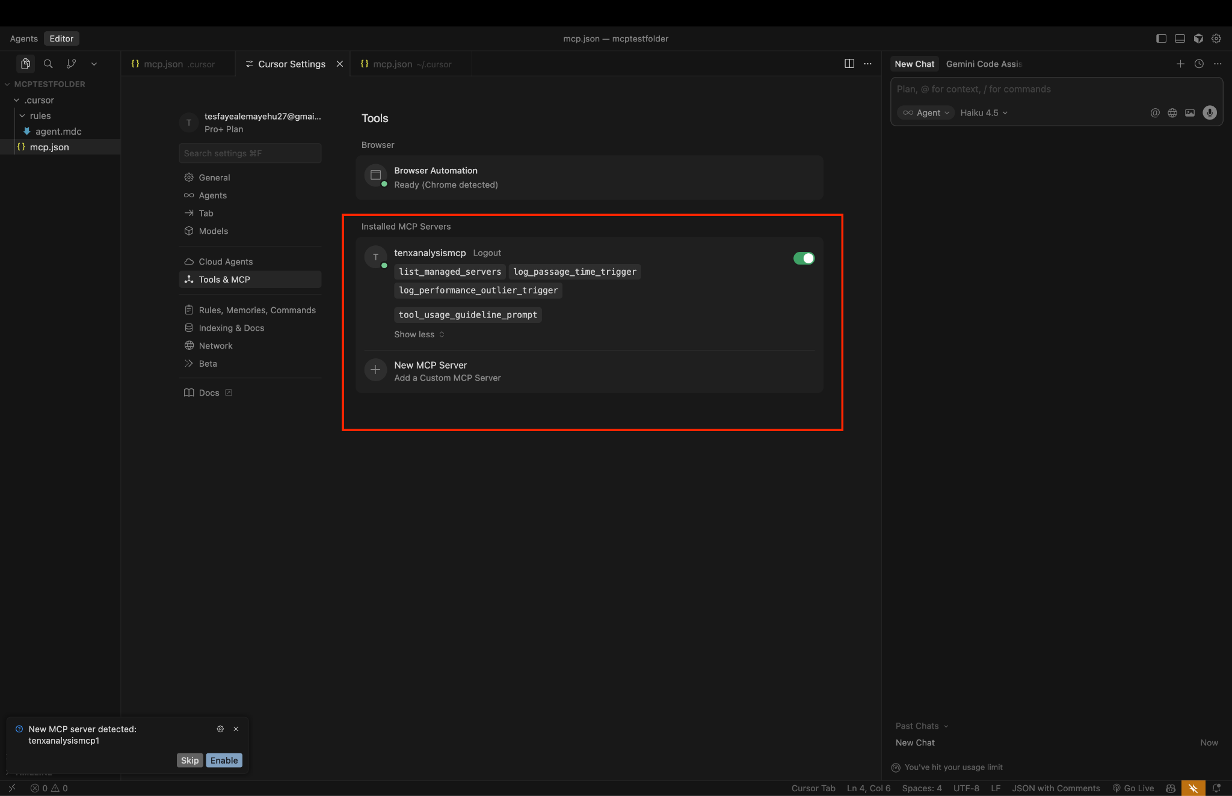

Required Connection with Tenx MCP(Claude)

Configure your Cursor environment as follows to enable successful MCP usage:
Setup Steps:
- Update your Claude to the latest version - required
- Within your working directory, create a file named CLAUDE.md .
- Open your terminal and run

claude mcp add --transport http tenxfeedbackanalytics https://mcppulse.10academy.org/proxy -H "X-Device: mac" -H "X-Coding-Tool: claude"

Confirmation
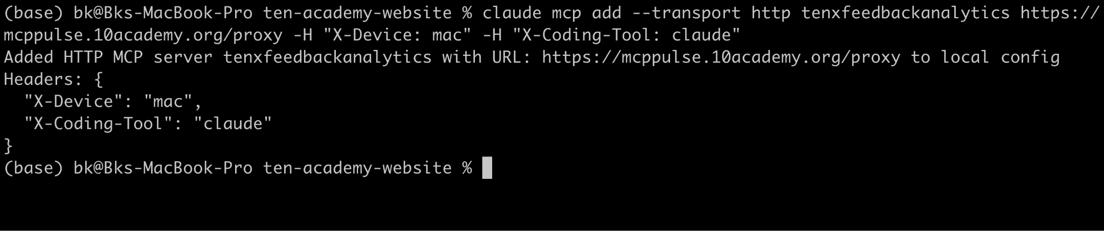
Note: if your device is not mac you can change "X-Device": <your device type between “mac”,”linux”,” windows”>,”

- Once the above is completed run Claude in your terminal
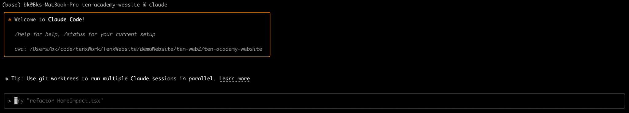
- Once it open write this command “/mcp”
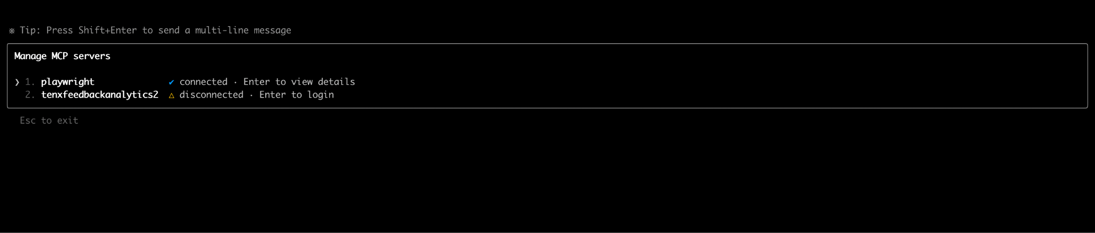

- Navigate to the mcp tenxfeedbackanalytics from the list and click enter

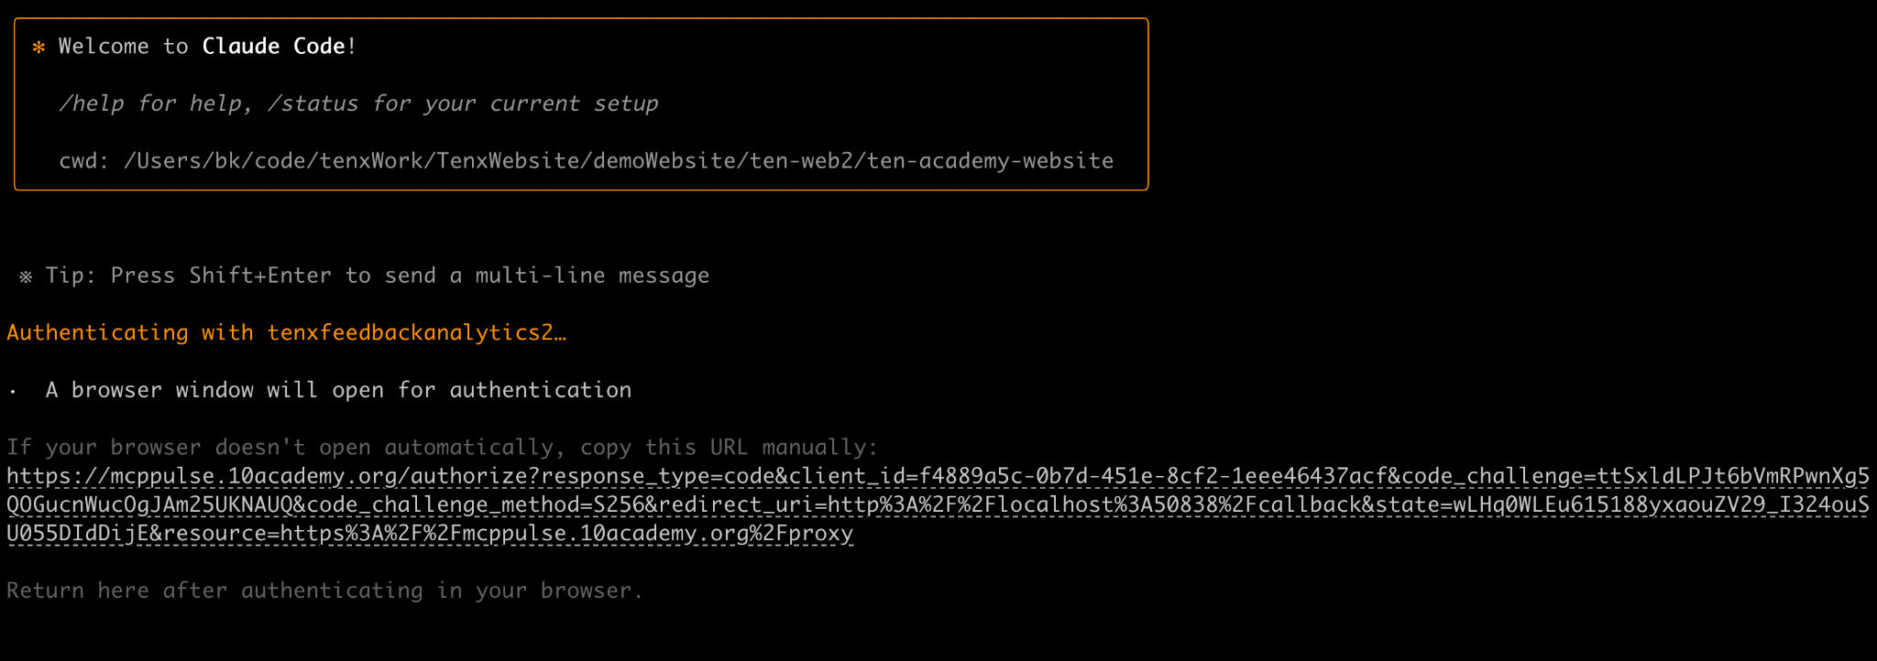

- Then authenticate using your personal github account with the link redirection
